Digital Booktalk
X-X klasse
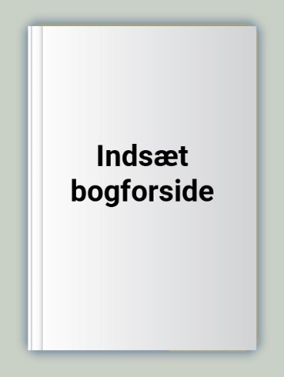  a a | a a | a a
a a | a a | a a
a a | a a | a a

